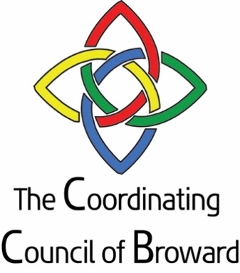

COORDINATING COUNCIL OF BROWARD COUNTY

September 6, 2022 12:00PM
Zoom Meeting

AGENDA

- Welcome Senator Nan Rich, Chair

- Approve minutes from July

- Chairperson update Senator Nan Rich, Chair

- Executive Director Report Sandra Veszi Einhorn
  - LTRC update
  - Housing Broward Master Plan

- Member updates and strategic initiatives
    - Children and Families
    - Mental Health
    - Homelessness
    - Workforce Development
    - Aging with Dignity
    - Prosperity Partnership
    - Public Safety

- Meeting Adjournment

Mission Statement: The mission of the Coordinating Council of Broward is to unite government, business and nonprofit leaders in advocacy and coordination of health and human services in Broward County.

Coordinating Council of Broward (CCB) is composed of the top executives of state and county entities from the public, private and business sectors, who are responsible for funding and implementing a broad array of health, public safety, education, economic and human services in Broward County. The Council’s goal is to better coordinate services and identify barriers that the ALICE (Asset Limited Income Constrained Employed) population experience. ALICE represents more than half of Broward County residents

Chair: Senator Nan Rich
Broward County Board of County Commissioners

Area Agency on Aging Broward County
Charlotte Mather-Taylor, CEO

Broward Behavioral Health Coalition
Silvia Quintana, CEO

Broward College
Isabel Gonzalez, Chief of Staff; VP of Communications and Community Relations

Broward 211
Sheila Smith, CEO

Broward County
Kimm Campbell, Deputy County Administrator

Broward Health
Shane Strum, CEO

Broward Regional Health Planning Council
Michael De Lucca, President and CEO

Broward Sheriff’s Office
Colonel Nichole Anderson, Undersheriff

Broward Workshop
Kareen Boutros, Executive Director

Career Source Broward
Carol Hylton, President

ChildNet
Larry Rein, President and CEO

Children’s Services Council
Cindy Arenberg Seltzer, President and CEO

Community Care Plan
Jessica Lerner, President and CEO

Community Foundation of Broward
Jennifer O’Flannery Anderson, President and CEO

Department of Children & Families
Dawn Liberta, Administrator

Department of Health in Broward County
Dr. Paula Thaqi, Director

Early Learning Coalition of Broward
Renee Jaffe, President and CEO

Greater Fort Lauderdale Alliance/Six Pillars
Ron Drew, Executive Director

Health Foundation of South Florida
Loreen Chant, CEO

Henderson Behavioral Health
Dr. Steven Ronik, President and CEO

Jewish Federation of Broward County
Evan Goldman, Executive Director, Public Affairs
Memorial Healthcare System
Tim Curtin, Executive Director, Community Services

Seventeenth Judicial Circuit
Joseph M. D'Amico, Esq., Trial Court Administrator

South Florida Regional Planning Council
Isabel Cosio Carballo, Executive Director

School Board of Broward County
Megan Turetsky, Director of Legislative Affairs and Community Relations
United Way of Broward County
Kathleen Cannon, Chief Executive Officer

