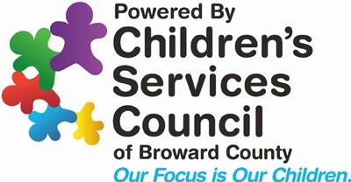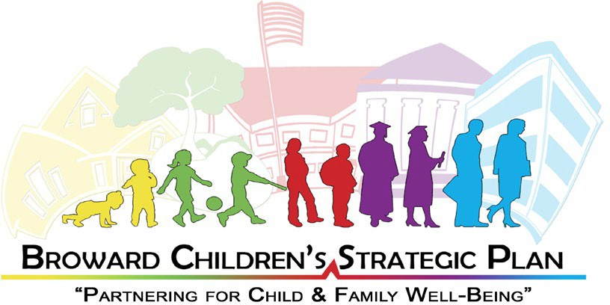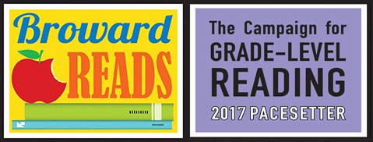

CAMPAIGN FOR GRADE-LEVEL READING
BROWARD READS COALITION MEETING
Wednesday, August 2, 2023, 9:30 a.m.

The meeting will be held via Zoom.

AGENDA
- Welcome 9:30 am

- Approval of June Meeting Minutes 9:33 am

- Updates:

  - Children’s Services Council (Cindy Arenberg Seltzer, Dr. Sharetta Remikie, Liza Khan)
    - General Updates 9:35 – 9:50 am

  - HandsOn Broward (Jenny Del Valle, Kathy Wint) 9:50 – 10:05 am
    - General Updates

  - Broward County Public Schools (Dr. Lori Canning, Melissa Holtz)
    - General Updates 10:05 – 10:20 am

  - Early Learning Coalition (Renee Jaffe, Allison Metsch) 10:20 – 10:35 am
    - General Updates

  - Broward County Libraries (Kimberly White) 10:35 – 10:50 am
    - General Updates

- Community Spotlight/Updates (Open Mic)

- Date of Next Meeting
All Meetings will be held at 9:30 a.m. on the first Wednesday of every other month. Upcoming meetings: October 4, December TBD.

- Adjourn Meeting

