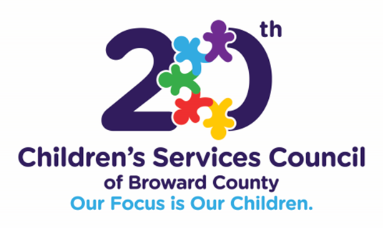

Wednesday, February 23, 2022
2:00 PM
Virtual via the Zoom Platform
Children’s Services Council of Broward County
6600 W. Commercial Blvd., Lauderhill, Florida 33319

MEETING AGENDA

- Welcome & Introductions Adamma DuCille, CSC Director of Equity &
Organizational Development

- Approval of Minutes Roxanne Smith, CSC Senior Training
Manager

- Panel Discussion Meet Our Racial Equity Cadre

- Dilys Schoorman
- Harleen Hutchinson
- Patricia Morgan
- Shantigra Williams
- Stephen Ferrante

- Closing Adamma DuCille

